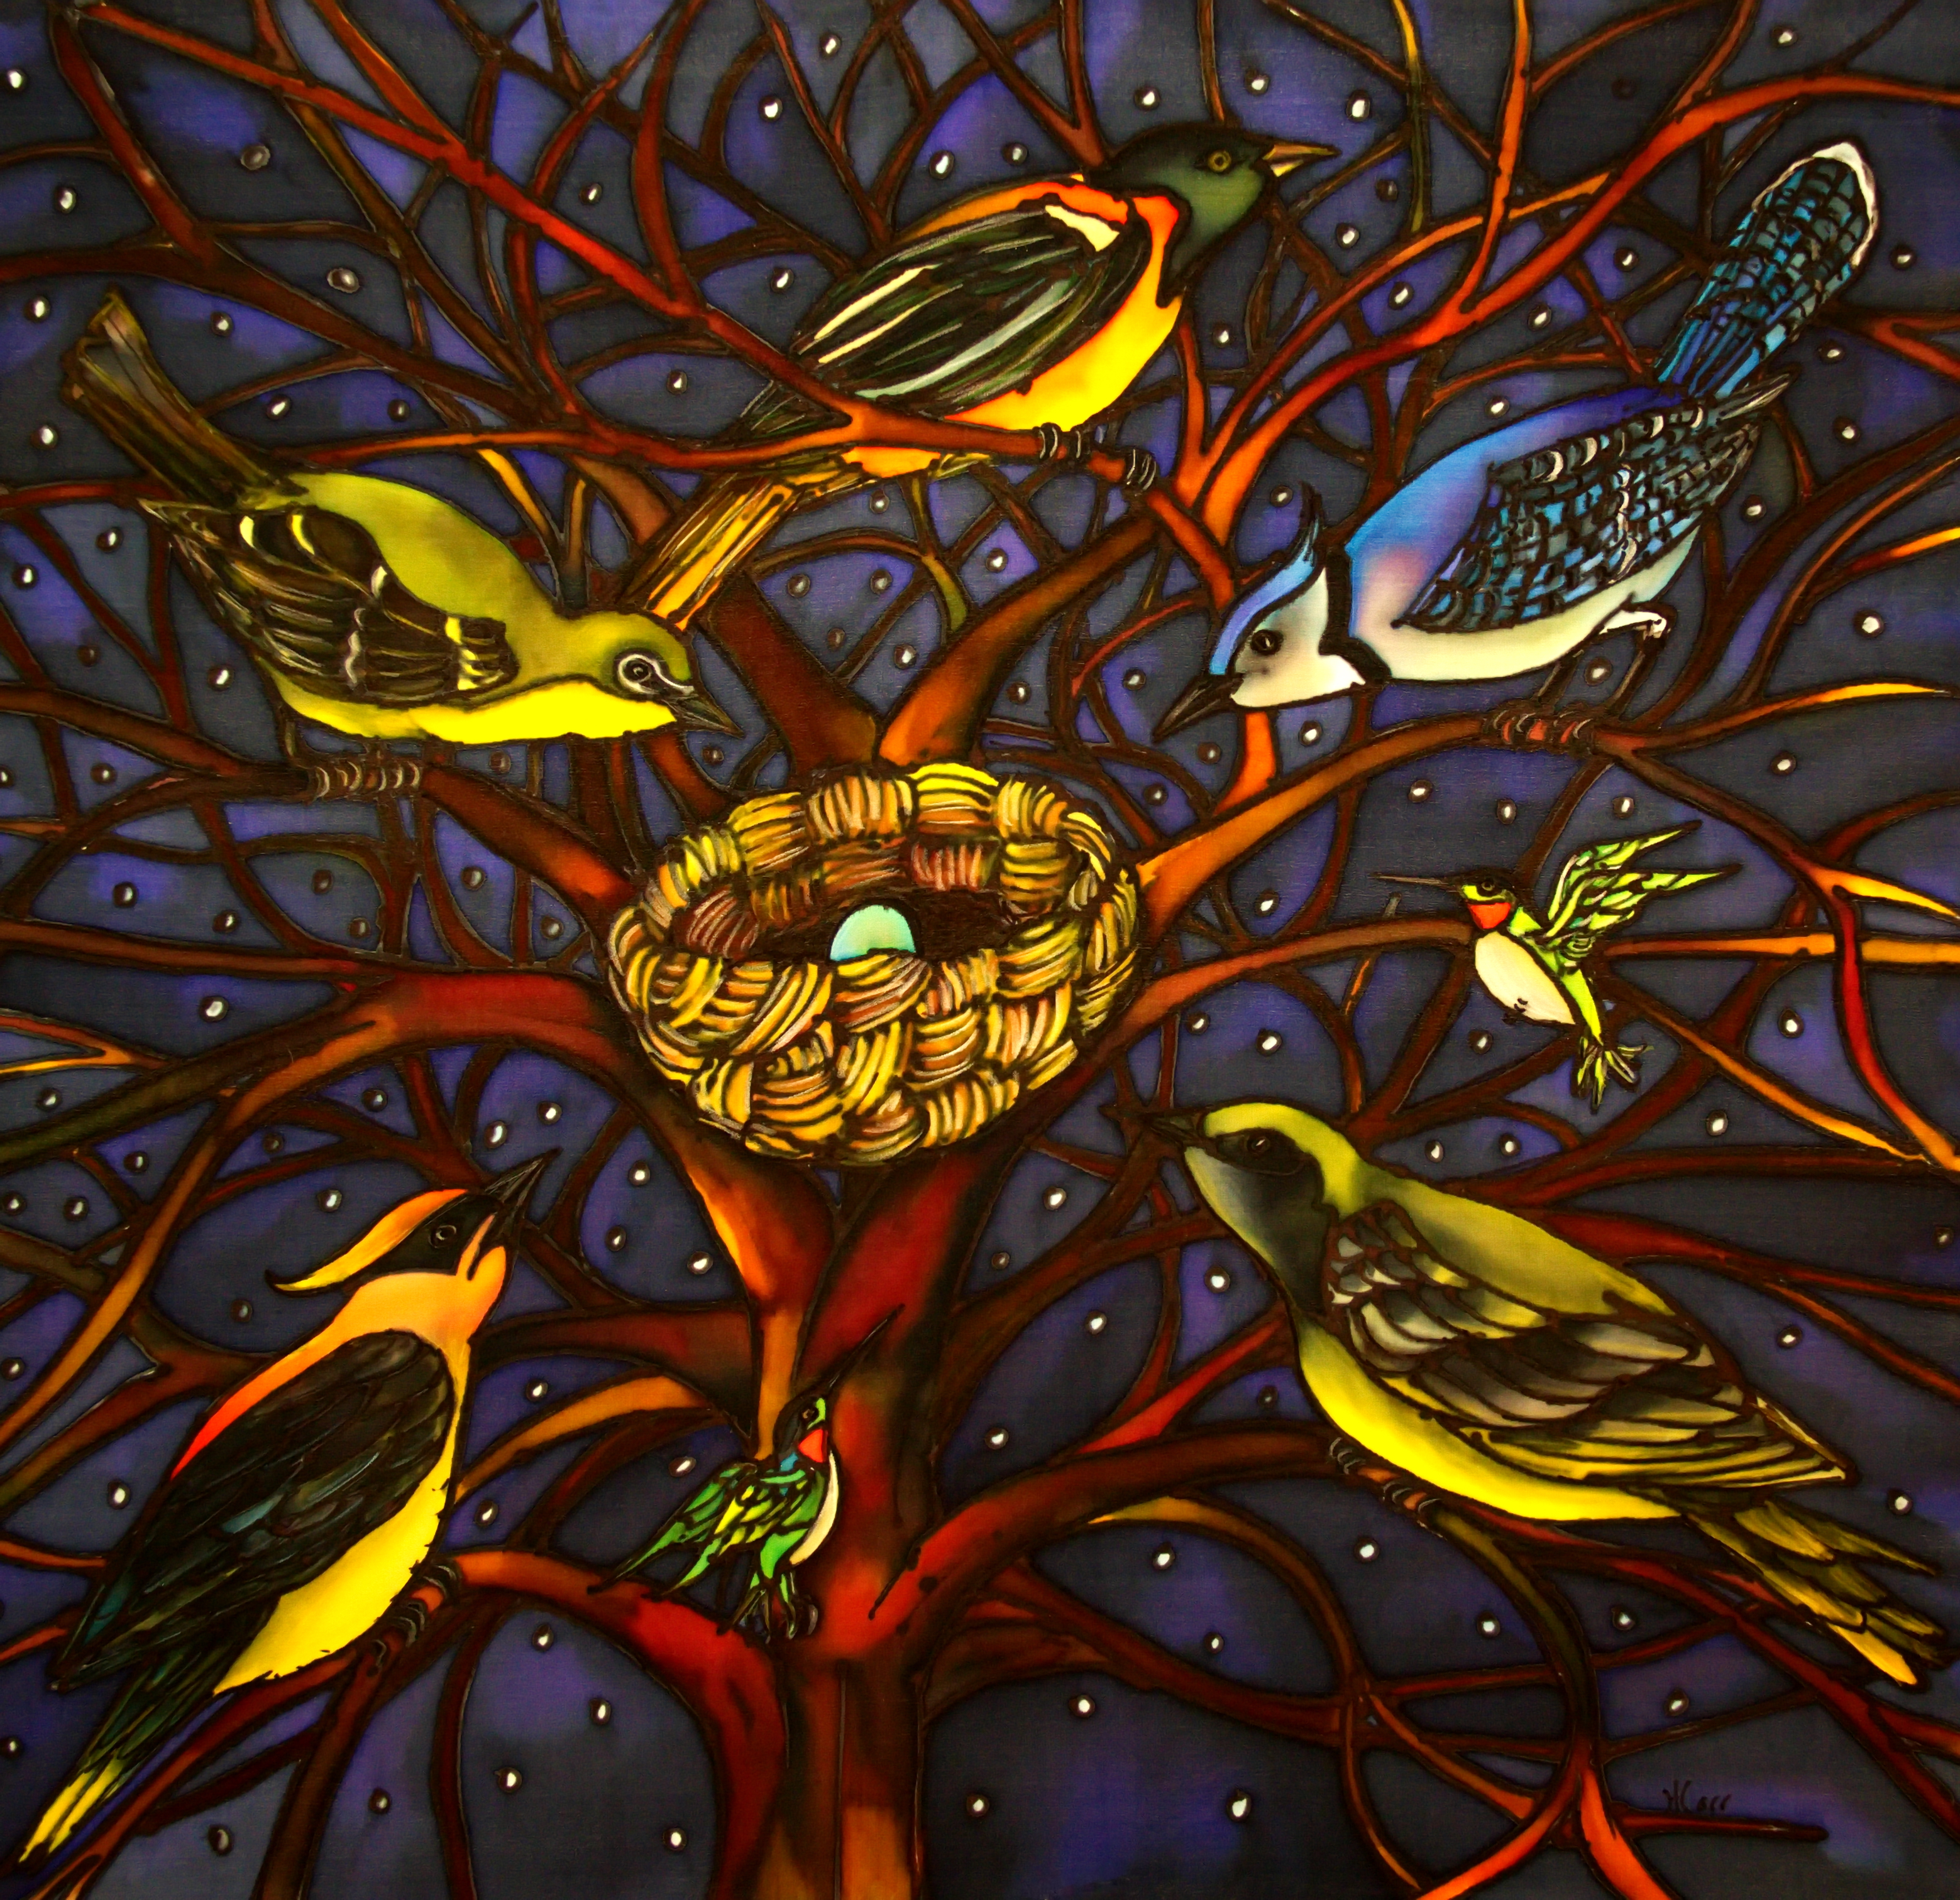
Art by Holly Carr
COMMUNITY SUICIDE PREVENTION GATHERING
REQUEST FOR FIBRE ARTISTS

Each year the Annapolis Valley branch of Communities Addressing Suicide Together organizes a community gathering where people across the Valley can come together to learn ways to navigate stress, support loved ones and themselves.

This year, the theme for the Suicide Prevention Gathering is “THE POWER OF COMMUNITY” and our symbol is the tree. The power of community is like the power of a tree. Each leaf a member of the community rising up to do their part in creating a kinder, more compassionate, more resilient community. With each unique leaf we come together and the tree is strengthened. Alone, a leaf can be tossed with every breeze, but together the tree can not only navigate the wind of change, it can grow with it.

We are asking local quilters, knitters, felters, fibre artists of any kind to contribute to this gathering by creating a leaf (or several!). These will then be distributed to all the participants (usually 120 people attend annually) where they will attach it to our community tree in honour of someone they care for and/or in honour of the commitment they are making to strengthen our collective community.

DETAILS:
- Leafs can be made of any fibre material as long as it can be attached to a central tree by sewing or hanging.

- Leaf dimensions are anywhere from 2.5-6”.

- Type of leaf is your choice … beech, maple, oak, aspen, imagination. Whatever your creativity encourages. Templates below are simply suggestions to be of support, not to limit your own ideas!

- Deadline is September 5th, 2016. Please contact Asha V Croggon to arrange for the leaves to be included. Email at ashavcroggon@gmail.com or cell 902.321.1296.

A thousand thanks for contributing to this important community heART project.
The completed work will be displayed at Community Health Centres and other gathering places across Annapolis Valley.

